
Voltage Booster

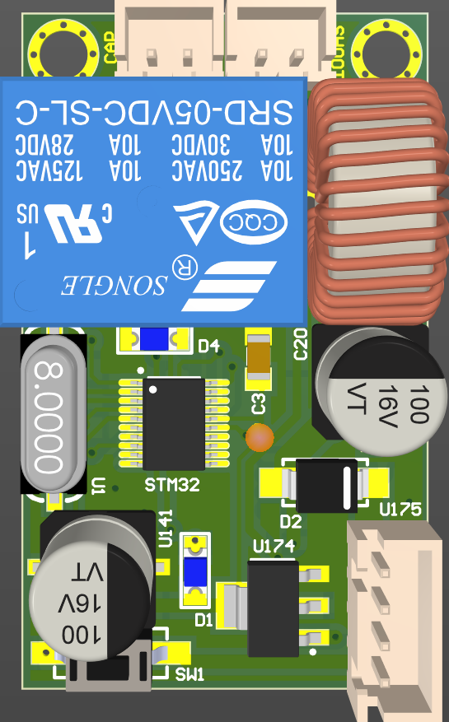

Introduction
This module is a voltage boost converter with 12v DC input and up to 90v DC output. The maximum current when charging the external capacitor is about 0.6A. This module is specifically designed to drive solenoids or any coil-based systems to perform a kick mechanism in special applications like soccer robots. It takes about 10 seconds to fully charge a 10000uF, 100v capacitor with a 12v DC input. The capacity will effect on charging time and the energy which is saved. Output voltage can be derived into the solenoid using the on-board relay controlled by a digital input pin working with both 5v and 3.3v logical level.

Power Supply
The recommended power supply is a 3-cells lithium polymer battery or any power source adaptors with more than 3A output current. General AA batteries in series connection are not recommended for these modules as they can’t supply required current. Experiments shows that using a 1000uF, 25v capacitor on input voltage can be helpful for discharge spikes. There is no need to connect 5v input by default because the module itself generates any required voltage level for itself using the 12v input.

Pinout
. 1 => Cap+
. 2 => Cap-

. 1 => Solenoid-
. 2 => Solenoid+

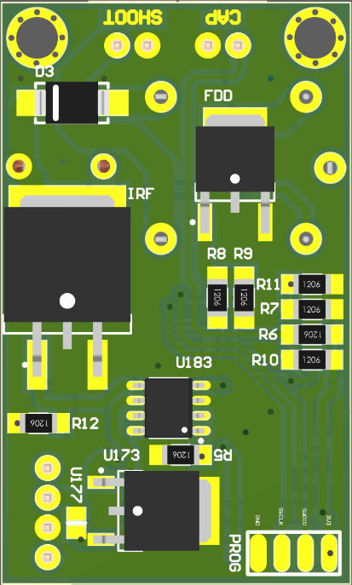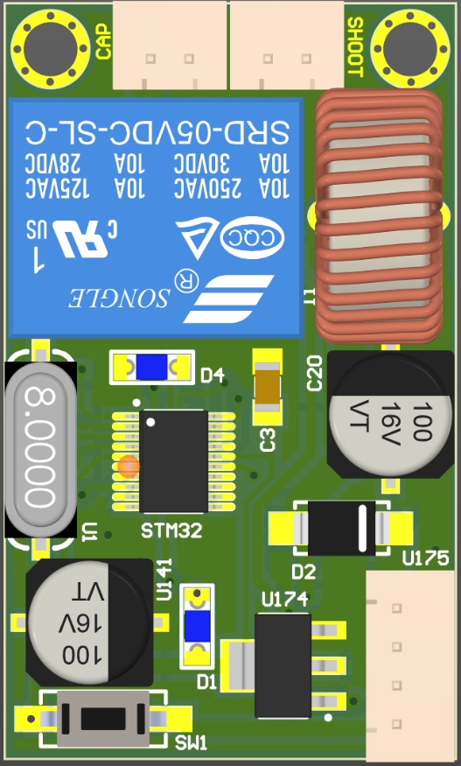
. 1 => +12v
. 2 => +5v (NC)
. 3 => GND
. 4 => Relay

Board Dimensions
